MEETING ROOM BOOKING SYSTEM

Software Requirement Specification

By
Mr. Thanarak Chumsawat 68543210018-6
Mr. Tanapat Chaitong 68543210064-0
Mr. Pathompon Leejang 68543210034-3
Mr. Pasit Petoumphun 68543210036-8
Mr. Wijitsin Fangyen 68543210068-1

Software Engineering, Department of Electrical EngineeringRajamangala University of Technology Lanna

Project Advisor
_____________________________

Mr. Sanya Uthayotha
Document Story
Version | Description | Date | Responsible | Status
Software  Requirement  Specification_V.0.1 | Initial Draft  - Add Chapter 1: Introduction  - Add Chapter 2: Overall Description  - Add Chapter 3: Functional Requirement | 8 Jan 2026 | TNR, PTP, PST | Draft
Software  Requirement  Specification_V.0.2 | Update Requirement  - Update URS based on feedback  - Add ER Diagram (Proposed) | 12 Jan 2026 | JTS, TNP | Reviewed
Software  Requirement  Specification_V.1.0 | First Release  - Finalize SRS for Phase 1 approval | 14 Jan 2026 | SANTACLAUS TEAM | Released

Acronym
TNR = Thanarak Chumsawat(Product Owner)
TNP = Tanapat Chaitong (Scrum Master)
PTP = Pathompon Leejang (Developer)
PST = Pasit Petoumphun (Developer)
JTS = Wijitsin Fangyen (Developer)

Table of content
Chapter One | Introduction ..................................................................................................................... 1
1.1 Objective .................................................................................................................................. 1
1.2 Project Scope ............................................................................................................................ 1
1.3 Acronyms and Definitions ....................................................................................................... 1
Chapter Two | Overall Description ........................................................................................................ 2
2.1 Product Perspective .................................................................................................................. 2
2.2 Product Features ....................................................................................................................... 2
2.3 User Classes and Characteristics .............................................................................................. 2
2.4 Operation Environment ............................................................................................................ 3
Chapter Three | Functional Requiremen ................................................................................................ 4
3.1 User Requirement Specification .............................................................................................. 4
3.2 User Requirement Specification with the Software Requirement Specification ..................... 4
Chapter Four | Specific Requirement .....................................................................................................6
4.1 Use Case Scenarios ................................................................................................................. 6
4.2 Use Case Description ...............................................................................................................7
Chapter Five | References .....................................................................................................................18

Chapter One | Introduction

1.1 Objective
The objective of this Software Requirement Specification (SRS) is to define the requirements for the "Meeting Room Booking System" (Internal Organization Meeting Room Reservation System), covering both Web Application and Mobile Application platforms. The primary goal is to create a seamless and accurate meeting space management system that eliminates location conflicts and ensures smooth collaboration within the organization. The system aims to support booking for the entire organization with a 0% double booking rate, allowing users to complete a reservation within 4 clicks and providing accurate notifications.
This document serves as a guideline for developers, project managers, and stakeholders to ensure a unified understanding of the system design and development.

1.2 Project Scope
The Meeting Room Booking System consists of a Web Application and a Mobile Application designed to resolve current pain points such as double bookings, unknown room status, and lack of notifications . The scope of the system includes:
- Feature #1: Real-time Availability & Booking: Display real-time room status (Green/Red) and allow self-service booking and cancellation.
- Feature #2: Conflict Detection: An algorithm to prevent time overlapping and ensure Zero Double Booking.
- Feature #3: Notification System: Send email confirmations immediately after booking and reminders before the meeting starts.
- Feature #4: Check-in & Auto-release: A check-in system to confirm usage and automatically cancel bookings if the user does not show up (solving Ghost Booking).
- Feature #5: Admin Management: Tools for administrators to manage room information (add/edit/delete) and room status (e.g., closed for maintenance).
- Feature #6: Approval Workflow: An approval system for VIP rooms or large conference rooms.
- Feature #7: Facility Reporting: A system for users to report damaged equipment in meeting rooms.

1.3 Acronyms and Definitions
- Double Booking: A situation where a meeting room is booked by multiple parties for the same time slot.
- Ghost Booking: A situation where a room is booked but no one shows up, causing the room to appear occupied in the system.
- PO (Product Owner): The person responsible for defining the product vision and backlog.
- SM (Scrum Master): The person responsible for facilitating the team and removing obstacles.
- Admin: The system administrator or building staff who manages room data and approvals.
- User: General employees who use the system to book rooms.

Chapter Two | Overall Description

2.1 Product Perspective
The Meeting Room Booking System is developed to replace the existing manual booking process, which relies on walking to check rooms, calling staff, or using paper/Excel logs, leading to delays and errors .
This new system operates as a centralized digital platform connecting General Users, Administration/Operations, and the System itself . It enables Self-Service Booking, allowing users to check status and book rooms via Web or Mobile App without waiting for a middleman, while the system automatically handles logic and verification to reduce human error .

2.2 Product Features
Based on User Needs and the Product Backlog, the major features are categorized as follows:
- Booking Management: Search for available rooms, create bookings, and cancel bookings, supporting both ad-hoc and recurring reservations.
- Access Control & Verification: Verify conditions for VIP rooms and require Check-in to confirm presence.
- Automated Alerts: Automatically send email notifications for confirmations and reminders.
- Administrative Tools: Manage room details, approve requests, and handle facility reports.
- History & Optimization: View booking history and provide smart room recommendations based on capacity.

2.3 User Classes and Characteristics
The users of the system are categorized by their roles and behaviors:
- General Employees (e.g., Marketing, Sales, Interns):
  - The largest user group. They need to book rooms quickly (Ad-hoc) and mostly use mobile phones. They require a user-friendly interface to reduce the learning curve.
- Planners & Secretaries (e.g., HR, Executive Secretary):
  - Users who manage schedules for others or organize training. They need Recurring Booking features and the ability to edit or swap rooms easily and accurately.
- Approvers & Executives (e.g., Gatekeeper, CEO):
  - Users with authority to approve large rooms or VIP rooms. Executives require privacy and priority booking.
- Support Staff (e.g., Admin, IT Support, Housekeeper):
  - Staff responsible for room maintenance and cleanliness. They need to see room status to perform their duties or block rooms for repairs.

2.4 Operation Environment
The system is designed to operate in a specific environment to ensure stability and performance. The following hardware and software configurations are required for the development and deployment of the "Meeting Room Booking System".
Hardware Interface The application has been tested and optimized for the following workstation specifications (Client/Development Side):
- Apple MacBook Pro M4
- HP Victus, HP Victus 16 (s0095ax)
- Acer Nitro V 15 (ANV15-51-50UV)
Software Interface The system utilizes the following software technologies and infrastructure for backend operations and deployment:
- Cloud Infrastructure: AWS EC2 (Amazon Elastic Compute Cloud)
- Database & Backend as a Service: Supabase (Superbase)
- Containerization: Docker
- Framework/Library: Antigravity

Chapter Three | Functional Requirement

3.1 User Requirement Specification
Feature #1 Booking System
URS-01: Users can view the real-time availability of meeting rooms on the web/mobile application.
URS-02: Users can create a booking by inputting date, time, room, topic, and number of attendees.
URS-03: Users can insure that the booking will not overlap with others (Zero Double Booking).
URS-04: Users can cancel their own booking on the application.
URS-11: Users can get a room recommendation based on the number of attendees.
URS-12: Users can view their own booking history.
Feature #2 Notification & Check-in System
URS-05: Users receive email confirmation immediately after booking and reminders before the meeting starts.
URS-06: Users must check-in to confirm the usage of the room to prevent ghost booking.
Feature #3 Policy & Fairness
URS-07: Users are limited to recurring bookings for a maximum of 4 weeks to ensure fairness.
Feature #4 Admin & Management System
URS-08: Administrators can manage room information (add/edit/delete) and room status.
URS-09: Administrators can approve or reject the request for VIP rooms.
URS-10: Users can report damaged equipment in the meeting room.

3.2 User Requirement Specification with the Software Requirement Specification
URS-01: Users can view the real-time availability of meeting rooms on the web/mobile application.
SRS-001: The system shall display a dashboard showing a calendar view of all meeting rooms.
SRS-002: The system shall indicate the status of each room using color codes (e.g., Green for Available, Red for Occupied).
SRS-003: The system shall load the availability status within 2 seconds.
SRS-004: The system shall update the status in real-time without requiring a manual page refresh.
URS-02: Users can create a booking by inputting date, time, room, topic, and number of attendees.
SRS-005: The system shall provide a "Create Booking" form.
SRS-006: The system shall require the user to input the Meeting Topic, Date, Start Time, End Time, and Number of Attendees.
SRS-007: The system shall display an error message "Cannot book past time" if the user selects a date/time in the past.
SRS-008: The system shall generate a unique Booking ID upon successful booking.
URS-03: Users can insure that the booking will not overlap with others (Zero Double Booking).
SRS-009: The system shall validate the requested time slot against the database before saving.
SRS-010: The system shall display an error message "Room is not available" if the requested time overlaps with an existing booking record.
SRS-011: The system shall lock the record during the transaction to prevent concurrent booking conflicts.
URS-04: Users can cancel their own booking on the application.
SRS-012: The system shall provide a "Cancel" button for active bookings in the user's dashboard.
SRS-013: The system shall allow cancellation only if the logged-in user is the owner of the booking (except Admin).
SRS-014: The system shall immediately update the room status to "Available" (Green) upon cancellation.
URS-05: Users receive email confirmation immediately after booking and reminders before the meeting starts.
SRS-015: The system shall send an automated email to the user's registered email address upon "Confirmed" status.
SRS-016: The email content shall include Date, Time, Room Name, and Meeting Topic.
SRS-017: The system shall send a notification/email reminder 15 minutes before the meeting start time.
URS-06: Users must check-in to confirm the usage of the room to prevent ghost booking.
SRS-018: The system shall display a "Check-in" button or QR Code scanner 15 minutes before and after the start time.
SRS-019: The system shall automatically change the booking status to "Cancelled" if the user does not check-in within 15 minutes after the start time.
SRS-020: The system shall release the room to be "Available" for others immediately after an auto-cancellation.
URS-08: Administrators can manage room information (add/edit/delete) and room status.
SRS-021: The system shall provide an Admin Dashboard for room management.
SRS-022: The system shall allow the Admin to disable a room (set status to "Maintenance" or "Inactive") temporarily.
SRS-023: The system shall update the user-facing calendar immediately when an Admin adds or removes a room.
URS-09: Administrators can approve or reject the request for VIP rooms.
SRS-024: The system shall set the initial status of bookings for VIP rooms to "Pending Approval".
SRS-025: The system shall notify the Administrator when a Pending request is created.
SRS-026: The system shall provide "Approve" and "Reject" buttons for the Administrator.
SRS-027: The system shall change the status to "Confirmed" only after the Administrator clicks "Approve".
URS-10: Users can report damaged equipment in the meeting room.
SRS-028: The system shall provide a "Report Issue" form allowing users to select the equipment (e.g., Projector, Air Conditioner).
SRS-029: The system shall send a notification to the Admin or IT Support upon submission of a report.
SRS-030: The system shall allow the Admin to block the room for maintenance based on the report.

Chapter Four | Specific Requirement
4.1 Use Case Scenarios
4.1.1 Use Case Diagram (Overall System)

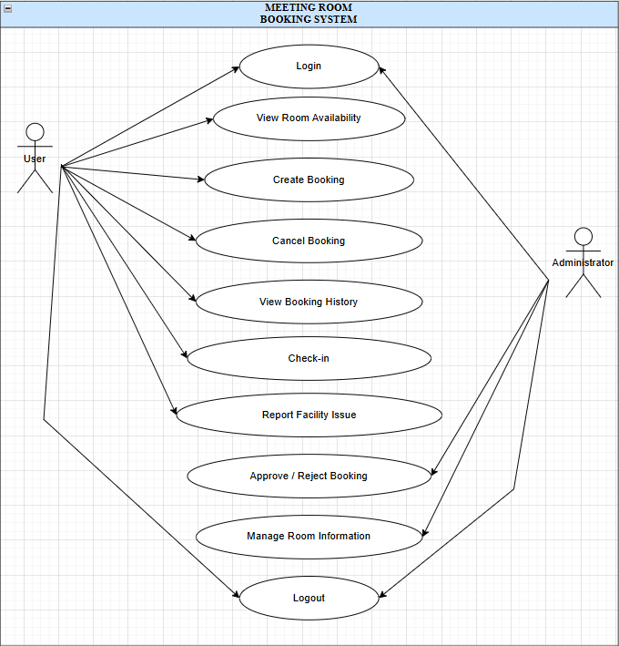

    - Use Case Diagram (Authentication System)
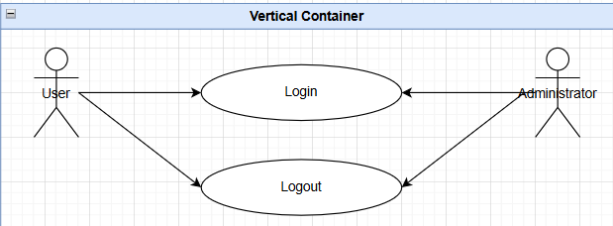

    - Use Case Diagram (Booking System)
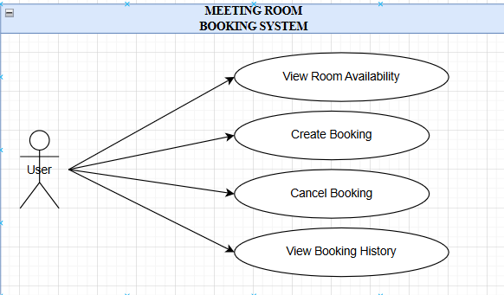

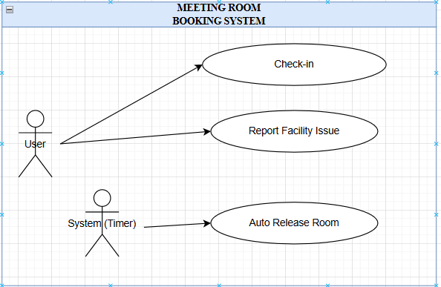
4.1.4 Use Case Diagram (Action & Notification System)

4.1.5 Use Case Diagram (Management System)
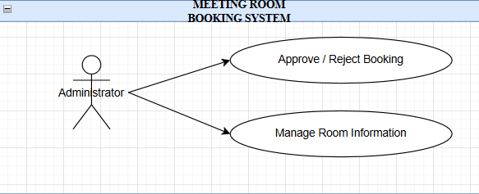

4.2 Use Case Description
4.2.1 Feature#1: Authentication System
UC-01: Users and Administrators can log in to the system to verify their identity and access specific features.
Topic | Description
Use Case Name | Login
Actor | User, Administrator
Description | Users log in to the system to access booking features and identify their roles.
Trigger | User opens the application or website.
Pre-conditions | User must have a registered account.
Post-condition | User is authenticated and redirected to the Dashboard.
Normal Flows | 1. User enters username and password.  2. System validates credentials against the database.  3. System identifies the user role (User or Admin).  4. System grants access to the main dashboard.
Exceptions | 1. Invalid Credentials: System displays "Invalid username or password" and asks the user to retry.

Activity Diagram :( AD-01):

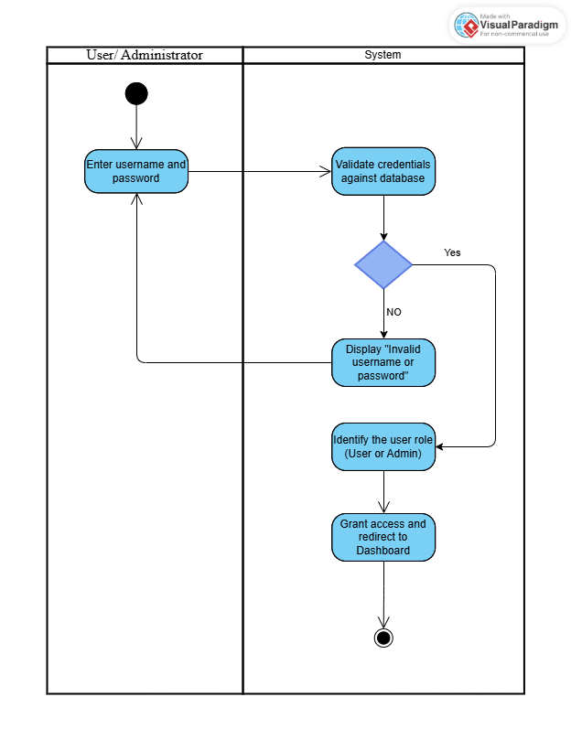

Feature #2: Booking System
UC-02: Users can view the real-time availability of meeting rooms on the dashboard.
Topic | Description
Use Case Name | View Room Availability
Actor | User
Description | Users view the real-time status of meeting rooms to find available slots.
Trigger | User navigates to the "Dashboard" or "Calendar" menu.
Pre-conditions | User is logged in.
Post-condition | System displays room status (Green=Available, Red=Occupied).
Normal Flows | 1. System retrieves booking data from the database.  2. System renders the calendar view with color-coded status.  3. User filters by date, time, or room capacity.

Activity Diagram :( AD-02):

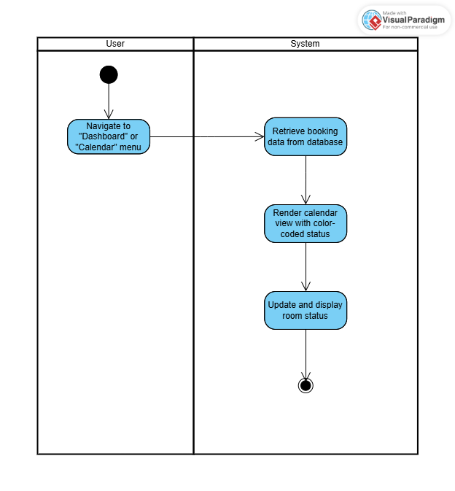

UC-03: Users can create a new booking by specifying the date, time, room, and meeting topic.
Topic | Description
Use Case Name | Create Booking
Actor | User
Description | Users create a new reservation for a meeting room.
Trigger | User clicks "Book Now" or selects a time slot.
Pre-conditions | The selected room must be available.
Post-condition | Booking is saved, and a confirmation email is sent.
Normal Flows | 1. User selects Date, Time, and Room.  2. User inputs Meeting Topic and Number of Attendees.  3. System performs Conflict Detection to ensure no overlap.  4. If General Room: System saves booking as "Confirmed".  5. If VIP Room: System saves booking as "Pending Approval".  6. System sends an email notification to the user.
Exceptions | 1. Double Booking: If the slot is taken during the process, system alerts "Room not available".  2. Past Time: System rejects bookings for past dates/times.

Activity Diagram :( AD-03):
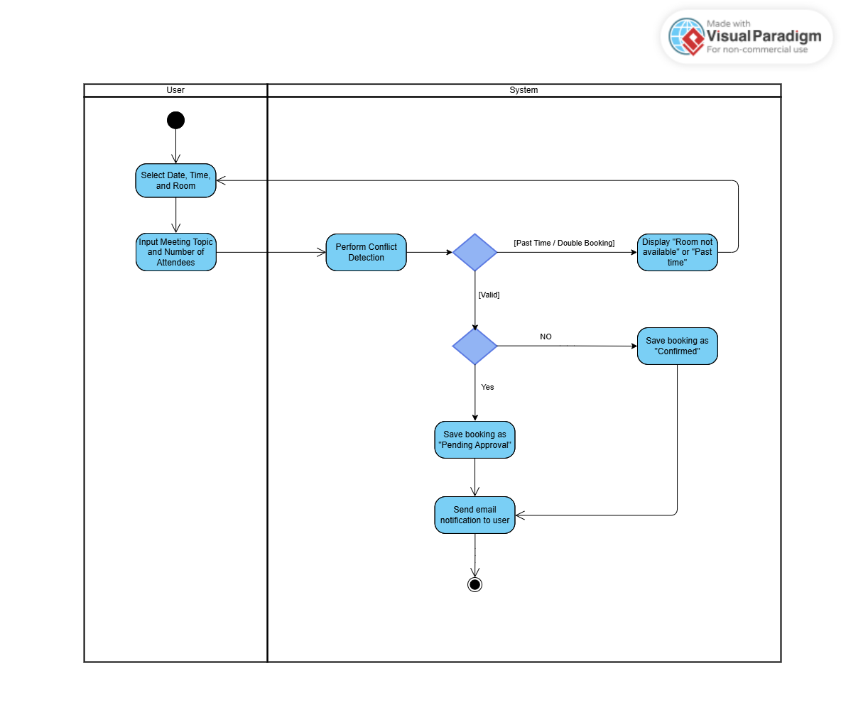
UC-04: Users can cancel their own active bookings to release the room for others.
Topic | Description
Use Case Name | Cancel Booking
Actor | User (Owner)
Description | Users cancel their own existing bookings.
Trigger | User clicks "Cancel" on a specific booking item.
Pre-conditions | The booking must not have expired.
Post-condition | Room status becomes "Available".
Normal Flows | 1. User views "My Bookings".  2. User selects a booking and clicks "Cancel".  3. System confirms the action.  4. System updates status to "Cancelled" and frees up the slot.

Activity Diagram :( AD-04):
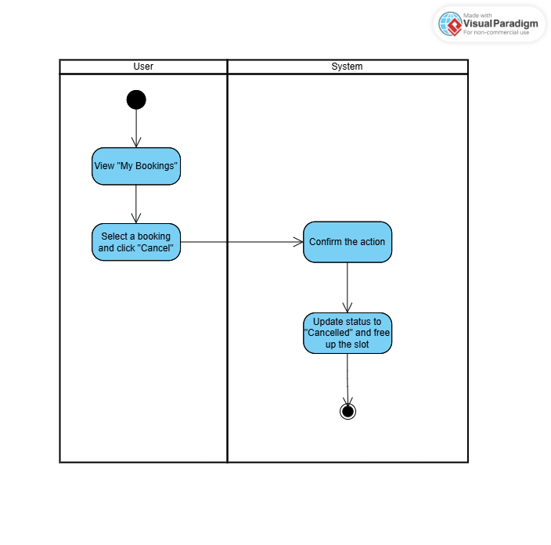

UC-05: Users can view a history of their past and upcoming meeting room reservations.

Topic | Description
Use Case Name | View Booking History
Actor | User
Description | Users view a list of their past and upcoming bookings.
Trigger | User selects "History" menu.
Pre-conditions | User is logged in.
Post-condition | A list of bookings is displayed.
Normal Flows | 1. System queries the database for bookings associated with the User ID.  2. System displays details (Date, Room, Status) sorted by date.

Activity Diagram :( AD-05):

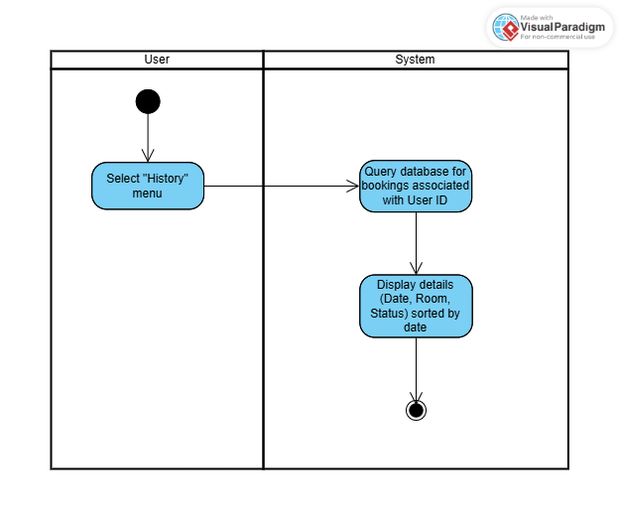

Feature #3: Action & Notification System
UC-06: Users can check-in at the meeting room to confirm their presence and prevent auto-cancellation.
Topic | Description
Use Case Name | Check-in
Actor | User
Description | Users confirm their presence to prevent "Ghost Booking".
Trigger | User arrives at the room within the specific timeframe (15 mins before/after start).
Pre-conditions | User has a valid booking for the current time.
Post-condition | Booking is marked as "Checked-in".
Normal Flows | 1. User opens the app or scans QR Code at the room.  2. User clicks "Check-in".  3. System verifies the time window.  4. System updates status to "Checked-in".
Exceptions | 1. Auto-Release: If no Check-in occurs within 15 minutes after start time, System automatically cancels the booking and releases the room.

Activity Diagram :( AD-06):

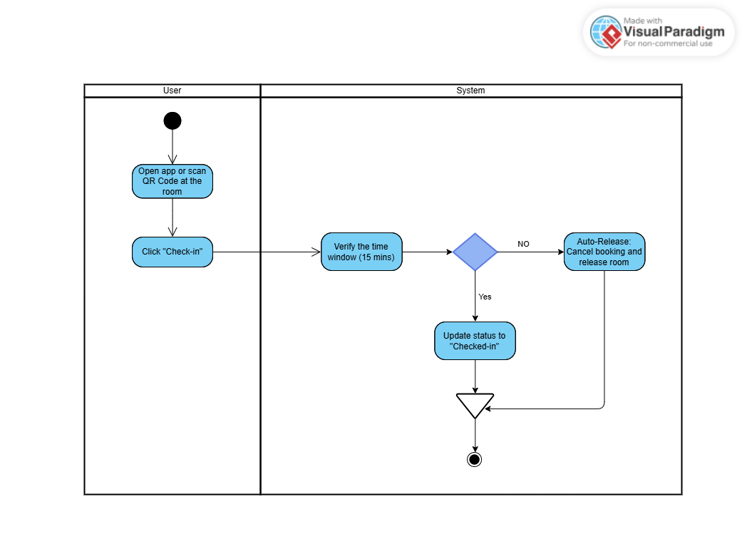

UC-07: Users can report damaged equipment or facility issues to the administration.
Topic | Description
Use Case Name | Report Facility Issue
Actor | User
Description | Users report damaged equipment (e.g., broken projector, air con).
Trigger | User clicks "Report Issue".
Pre-conditions | User is logged in.
Post-condition | Admin receives a notification.
Normal Flows | 1. User selects the room and the faulty equipment.  2. User adds details or photos.  3. System saves the report and notifies Admin/IT Support.

Activity Diagram :( AD-07):

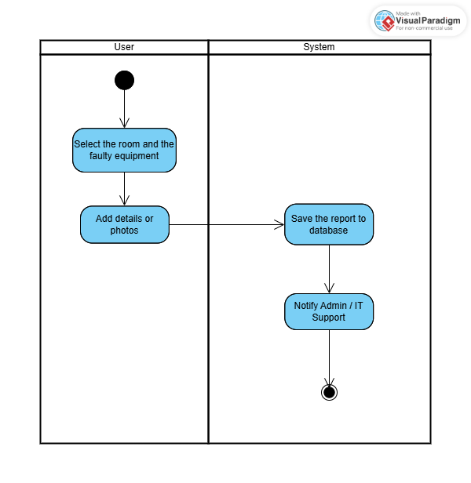

Feature #4: Management System
UC-08: Administrators can approve or reject booking requests for VIP meeting rooms.
Topic | Description
Use Case Name | Approve/Reject Booking
Actor | Administrator
Description | Admins review and decide on booking requests for VIP rooms.
Trigger | Admin receives a "Pending Approval" request.
Pre-conditions | A VIP room booking request exists.
Post-condition | Booking status changes to "Confirmed" or "Cancelled".
Normal Flows | 1. Admin views the list of pending requests.  2. Admin reviews the meeting purpose and requester.  3. Admin clicks "Approve".  4. System updates status to "Confirmed" and emails the user.
Alternate Flows | 3a. Reject: Admin clicks "Reject" and provides a reason. System updates status to "Cancelled".

Activity Diagram :( AD-08):
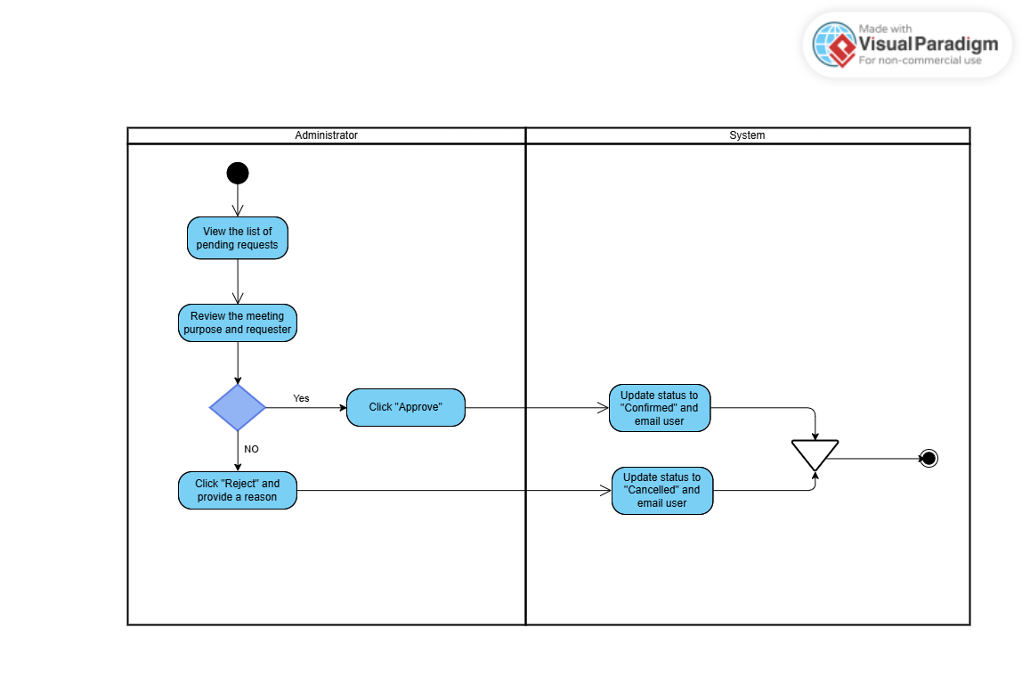

UC-09: Administrators can add, edit, or disable meeting room information in the system.

Topic | Description
Use Case Name | Manage Room Information
Actor | Administrator
Description | Admins add, edit, or disable meeting rooms in the system.
Trigger | Admin accesses "Room Management".
Post-condition | Database is updated with new room details.
Normal Flows | 1. Admin selects "Add Room" or "Edit Room".  2. Admin inputs room name, capacity, and facilities.  3. System saves the information.  4. New room info is immediately visible to users.

Activity Diagram :( AD-09):

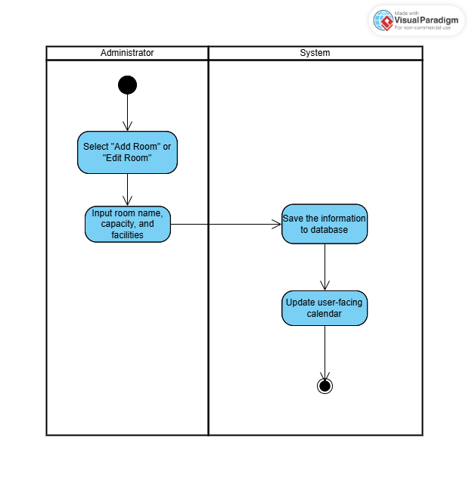

Chapter Five | References

[1] Definition of User Interface.
http://searchsoa.techtarget.com/definition/user-interface

[2] Definition of Use Case Diagram.
https://www.visual-paradigm.com/guide/uml-unified-modeling-language/what-is-use-case-diagram/

[3] Definition of Activity Diagram.
https://www.visual-paradigm.com/guide/uml-unified-modeling-language/what-is-activity-diagram/

